**March**

‘14

© **Madusha Perera | Dhammini Fernando | Virtusa (Pvt.) Ltd**

08

**Fall**

Prefatory Document HangIn Application - (iOS)

# Preface

This is an effort to change usual electronic invitations into much sense, where customer has his/her own invitation box without mixing up with other letters in their electronic letterbox.

It could be argued about the specificity of this mobile invitation box, which is where we come to the hit point of the application. Unlike being a mobile invitation box, it could be rather said that, *HangIn* becomes the partnership to help the user in any action during the roadmap from receiving an invitation to the going to the event.

As mobile becomes as part of daily routine, our rituals turn out to be much easier without worries. With regards to millennial mobile applications, mobile wallets become much friendlier than physical payments as user can proceed with a single click without having any physical overloads.

*HangIn* is a topnotch for regular invitation apps augmenting shopping cart within enabling mobile payments. Also, this could be an excellent opportunity from merchant’s perspective even though they could be small retailers. Hence this gives much extraordinary experience to the user having mobile assistance by the side reminding, contacting, navigating and directing perceptively throughout to the venue.

Table of Contents

Preface 2

1.0 Business Scenario 4

1.1 What made us step in: 4

1.2 What made us think different: 5

2.0 Release Plan 6

3.0 Design Diagrams 7

4.0 Wireframes 8

# 1.0 Business Scenario

## What made us step in:

## What made us think different:

Following is what made us inspirational to walk in: **Google Events**

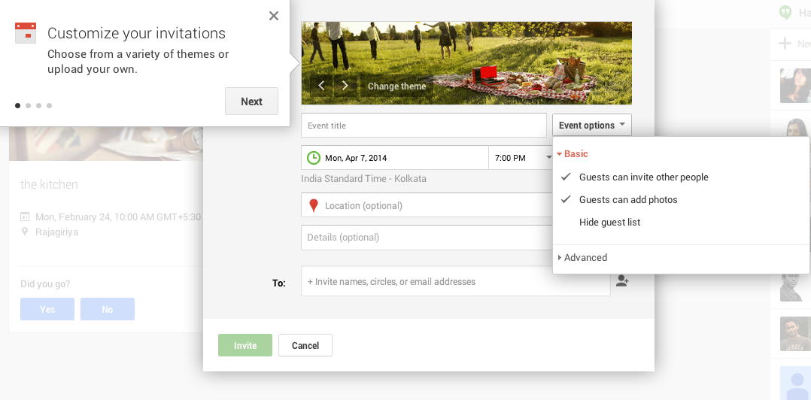

## 

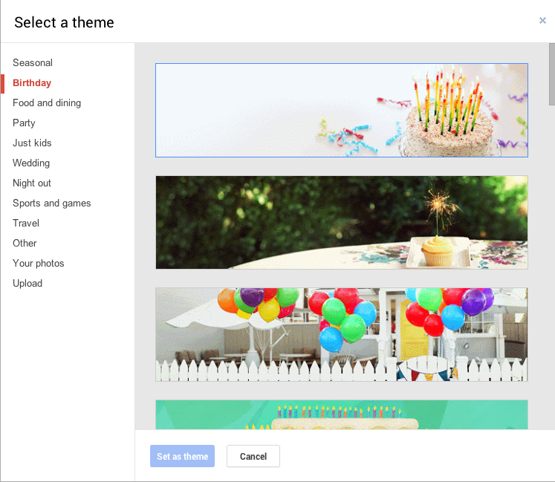

Google Event Has:

* Event Invitation
* Calendar Sync up
* Theme Selection
* Road Map

Google Events Lacks:

* Providing separate box to maintain inbox and outbox events
* Shopping cart which provides buying gifts to the events
* Mobile Payments
* Contacting Inviter

# 2.0 Release Plan

|  |  |  |
| --- | --- | --- |
| Milestone | Phase | Features on hand |
| 15 Apr 2014 | 1.0 | * Inbox * Outbox * Compose * Call/ Email * QR Scanning |
|  | 1.0.1 | * Local Notifications * Calendar sync up |
|  | **Release 1.0 alignment with App store terms** | |
|  | 1.1 | * Shopping Cart Facility * Mobile Payments |
|  | **Release 1.2 alignment with App store terms** | |
|  | 1.2 | * Website for new merchants * Facebook advertising * API Documentation * Labeling pricing * Setting up the bank account |
|  | **App store submission**  **Launching the application – Advertising** | |
|  |  |  |
|  |  |  |

# 3.0 Design Diagrams

# 4.0 Wireframes